SMART HOME

(DOOR ALARM USING ARDUINO UNO AND

ULTRA SONIC SENSOR)

**SUBMITTED BY:**

**GOPIKA SUNEESH .A.S**

**ROLL: 960219106066**

**DEPARTMENT OF ECE**

**INTRODUCTION:**

This **Arduino Controlled Door alarm** can be installed near the door to detect the presence of anybody at the door. Whenever somebody comes in the range of Ultrasonic sensor, buzzer starts beeping. You can adjust the sensor detection range according to your door. This system can also serve the purpose of **Motion Detector**.

**Ultrasonic sensor HC-SR04** is used here to detect the presences of any person at the door. The sensor module consists of ultrasonic transmitter, receiver and the control circuit. Ultrasonic Sensor consists of two circular eyes out of which one is used to transmit the ultrasonic wave and the other to receive it.

**COMPONENTS:**

Computer: This is required to write program and flash program to the

Controller. Also, you need to install Arduino IDE which is available free onthe Arduino website download section.

• Controller: I used Arduino micro-controller

• Sensor: I used HR SC-04 ultrasonic sensor.

• Piezo Buzzer: I used Piezo buzzer to make the audio warning.

• Wires: Jumper wires are required to make hardware connections. You need to use all types of jumper wires like male-male, female-female and female-male.

**CODE:**

//Door Alarm Using Arduino UNO and Ultrasonic Sensor//

// gopika suneesh //

int trigger_pin = 2;

int echo_pin = 3;

int buzzer_pin = 10;

int time;

int distance;

void setup()

{

Serial.begin (9600);

pinMode (trigger_pin, OUTPUT);

pinMode (echo_pin, INPUT);

pinMode (buzzer_pin, OUTPUT);

}

void loop()

{

digitalWrite (trigger_pin, HIGH);

delayMicroseconds (10);

digitalWrite (trigger_pin, LOW);

time = pulseIn (echo_pin, HIGH);

distance = (time * 0.034) / 2;

if (distance <= 10)

{

Serial.println (" Door Open ");

Serial.print (" Distance= ");

Serial.println (distance);

digitalWrite (buzzer_pin, HIGH);

delay (500);

}

else {

Serial.println (" Door closed ");

Serial.print (" Distance= ");

Serial.println (distance);

digitalWrite (buzzer_pin, LOW);

delay (500);

}

}

**FIGURE:**

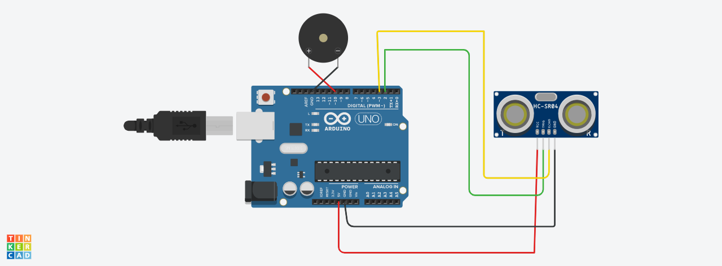

**TINKERCAD LINK:**

**[https://www.tinkercad.com/things/dcqHsqNPJpn](.)**